MATOSHRI MOTOR (RTO WORK MANAGEMENT PROJECT)

INTRODUCTION

Hardware Specification-

(Recommended)

1. Operating System:-Microsoft Windows 7/8/10
2. Processor: - Intel Pentium 4 or above.
3. Hard disk: - 40 GB or above.
4. 256 MB RAM

Software SpecificationEditor:

1. NetBeans 8.2 IDE
2. Back End: Apache derby
3. Platform : JDK 1.8

Scope of project:

This is the “RTO WORK MANAGEMENT SYSTEM” website which is used by the public. Who can getting the information and apply for Leaning or Driving Licenses .

Objectives of System:

The objectives of this application are as follows:

• This is the “RTO WORK MANAGEMENT SYSTEM” application provides the

information and apply for Leaning or Driving Licenses .

• The main purpose of this project is provide the all information and

Apply for licences and registrering vehical.

• This application is windows based.

• who want’s licences or registrer vehical they can use this application.

• It saves the time of finding the RTO office in your city.

• The application provide the apply for licences and register

vehical with details and documentation .

2.SYSTEM STUDY &ANALYSIS

2.1. Existing System:

* In the existing system the in this project the person can finding the shop of
* plumbing materials in the city and buying the require item of plumbing. This system
* is a lot of human and paper work and time wasting concept. The user can not get the
* all information about the products.
* System analysis is a detailed study of the various operations performed by a
* system and their relationships within and outside of the system. During analysis, data
* collected on the various files, decision points and transaction handled by the present
* system.
* Some analysis can be categorized into four parts:
  + System planning and initial investigation.
  + Information gathering.
  + Applying analysis tools for structured analysis.
  + Feasibility study.
  + Cost or Benefit analysis.

2.2. Proposed System:

* In our proposed system we have the provision for adding the details and create the account of the employee. Another advantage of the system is that it is very easy to edit the details of employee and delete employee when it found unnecessary. This website is open to public and end user can come here and browse desired plumbing items. We are developing an admin panel where our reputed employee can check day wise uploads editing happen by authorized employee. We are uploading the items of all categories happen in the plumbing and it will be maintained by using database and real time algorithm.
* User friendly interface.
* Fast access to database.
* The system makes the overall project management much easier and flexible.
* Less error.
* More storage capacity.
* Search facility

2.3. Feasibility Study:

The basic idea behind feasibility study is to determine whether the project is

feasible or not. A feasibility is conducted to identify a best system that meets all the

requirements. This includes an identification, description, an evaluation of the

proposed systems and selection of the best system for the job.

The requirements of the system are specified with a set of constraints such as

system objectives and the description of the out puts. It is then duty of the analyst to

evaluate the feasibility of the proposed system to generate the above results. Three

key factors are to be considered during the feasibility study.

2.3.1. Project Feasibility -

1. Operation Feasibility

An estimate should be made to determine how much effort and care will go

into the developing of the system including the training to be given to the user.

Usually, people are reluctant to changes that come in their progression. The computer

initialization will certainly affected the turn over, transfer and employee job status.

Hence an additional effort is to be made to train and educate the users on the new way

of the system.

2. Technical Feasibility

The main consideration is to be given to the study of available resources of the

organization where the software is to be implemented. Here the system analyst

evaluates the technical merits of the system giving emphasis on the performance,

reliability, maintainability and productivity.

By taking the consideration before developing the proposed system, the resources

availability of the organization was studied. The organization was immense computer

facilities equipped with sophisticated machines and the software hence this

technically feasible.

3. SYSTEM DESIGN

3. System Design:

3.1.DFD (Data Flow Diagram):

Context Level DFD:-

USERER

ADMIN

LOGIN

VIEW LINCENCE AND VEHICAL DETAILS

1 st level DFD Admin-

2 nd level DFD – Admin



ERD- Entity Relation Diagram-

**Field**

**Type**

**Constraints**

UNAME

VARCHAR (100)

NOT NULL

3.3. Database Design:

1.LEARNING TABLE :

|  |  |  |
| --- | --- | --- |
| **FIELD** | **DATATYPE** | **CONTAINTS** |
| APPLICATION NO | INTEGER(300) | UNIQUE/PRIMERY |
| FIRST NAME | VARCHAR (100) | NOT NULL |
| LAST NAME | VARCHAR (100) | NOT NULL |
| PINCODE | VARCHAR (100) | NOT NULL |
| MOBILE NO | VARCHAR (100) | NOT NULL |
| RTO OFFICE | VARCHAR (100) | NOT NULL |
| VEHICAL TYPE | VARCHAR (100) | NOT NULL |
| DATE OF BIRTH | VARCHAR (100) | NOT NULL |
| UPLOAD PHOTO | VARCHAR (3000) | NOT NULL |

2.USER REGISTRATION TABLE :

|  |  |  |
| --- | --- | --- |
| **FIELD** | **DATATYPE** | **CONTAINTS** |
| USERNAME | VARCHAR (50) | NOT NULL |
| PASSWORD | VARCHAR (100) | NOT NULL |
| FIRST NAME | VARCHAR (100) | NOT NULL |
| LAST NAME | VARCHAR (100) | NOT NULL |
| CITY | VARCHAR (100) | NOT NULL |
| ADDRESS | VARCHAR (100) | NOT NULL |
| MOBILE NO | VARCHAR (100) | NOT NULL |
| EMAIL | VARCHAR (100) | NOT NULL |

2.SLOT BOOKING TABLE :

|  |  |  |
| --- | --- | --- |
| **FIELD** | **DATATYPE** | **CONTAINTS** |
| APPLICATION NO | INTEGER(300) | PRIMERY/UNIQUE |
| DATE | VARCHAR (100) | NOT NULL |

2.VEHICAL REGISTRATION TABLE :

|  |  |  |
| --- | --- | --- |
| **FIELD** | **DATATYPE** | **CONTAINTS** |
| VEHICAL NO | VARCHAR (50) | NOT NULL |
| CHASSI NO | VARCHAR (100) | NOT NULL |
| OWNER NAME | VARCHAR (100) | NOT NULL |
| VEHICAL TYPE | VARCHAR (100) | NOT NULL |
| VEHICAL PERCHASE YEAR | VARCHAR (100) | NOT NULL |
| MOBILE NO | VARCHAR (100) | NOT NULL |

4. OUTPUT SCREENS

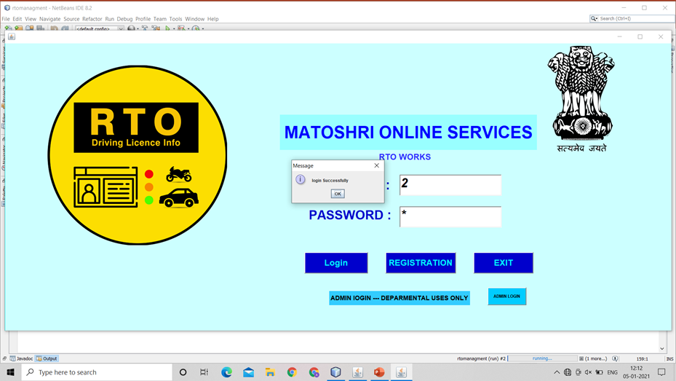

THIS IS USER LOGIN PAGE

2. PAGE NO

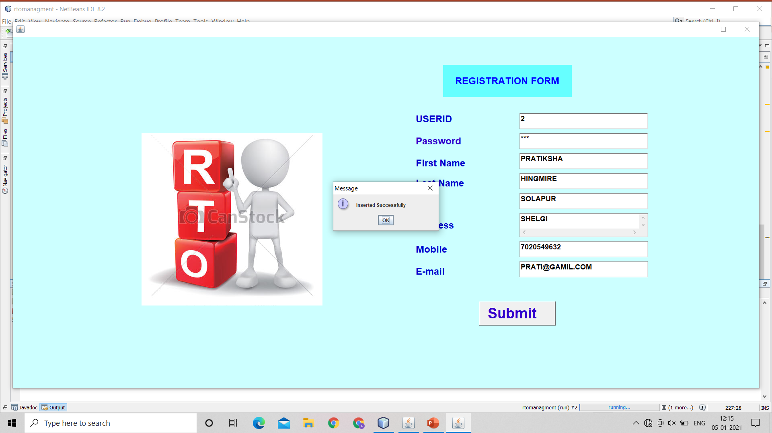

THIS IS USER LOGIN REGISTRATION PAGE

3. PAGE NO



THIS IS USER LOGIN REGISTRATION PAGE

3.HOME PAGE

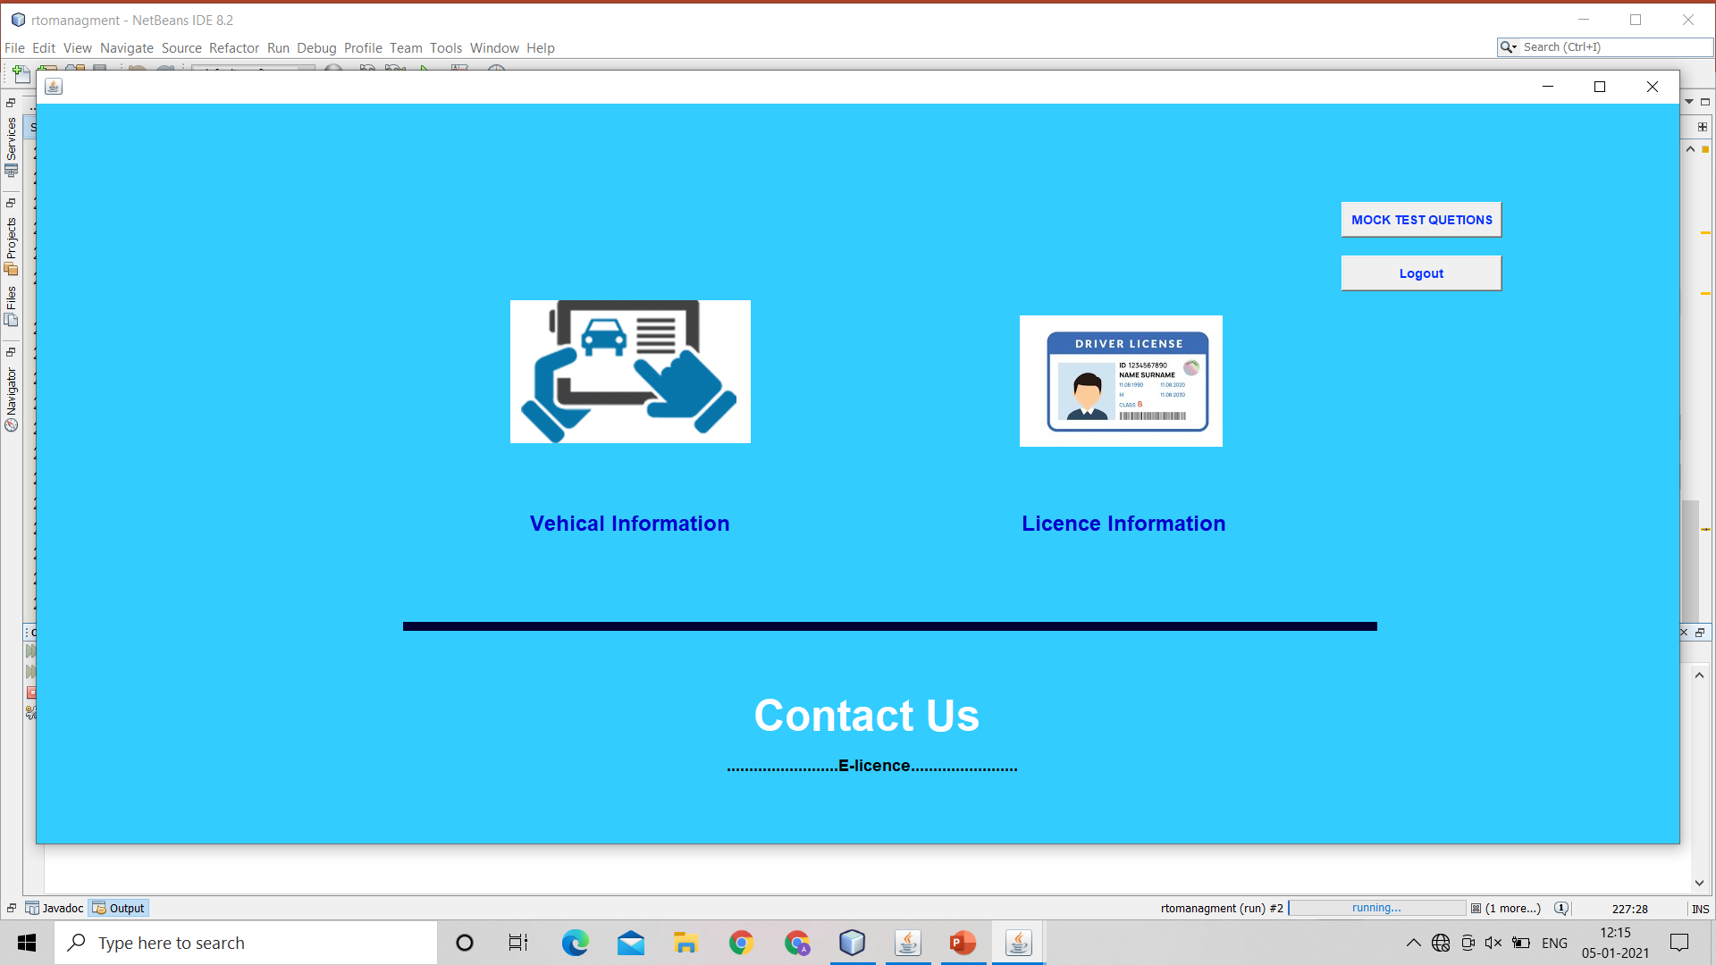

THIS IS USER HOME FOR USER PAGE

4.PAGE NO

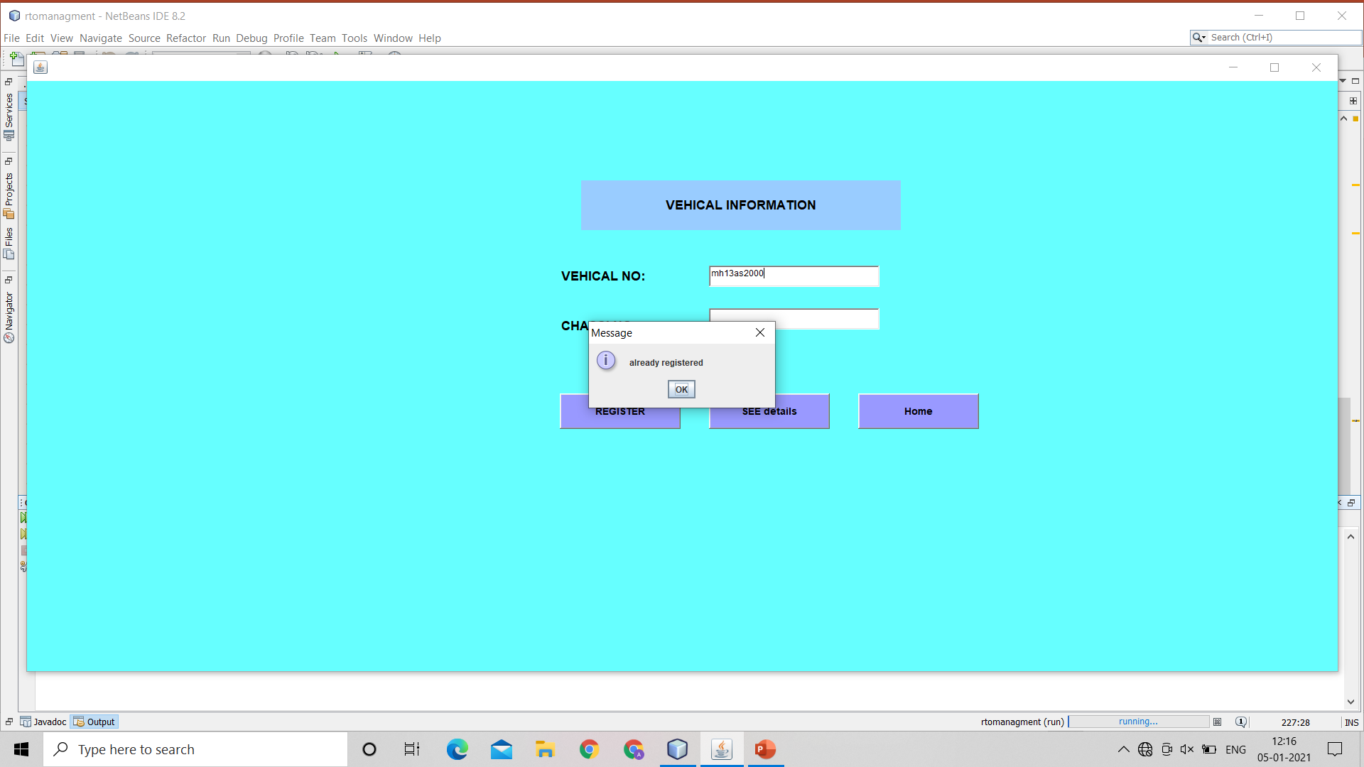

THIS IS VEHICAL INFORMATION PAGE

5.PAGE NO

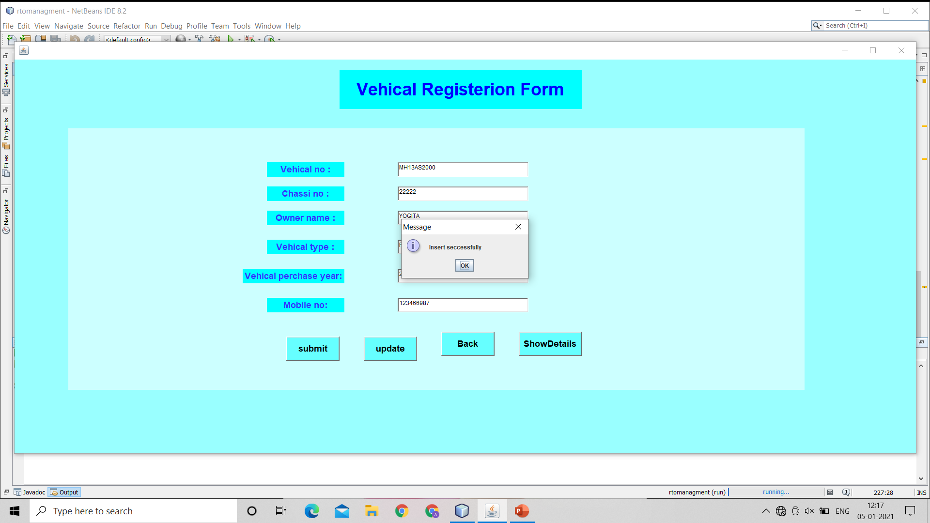

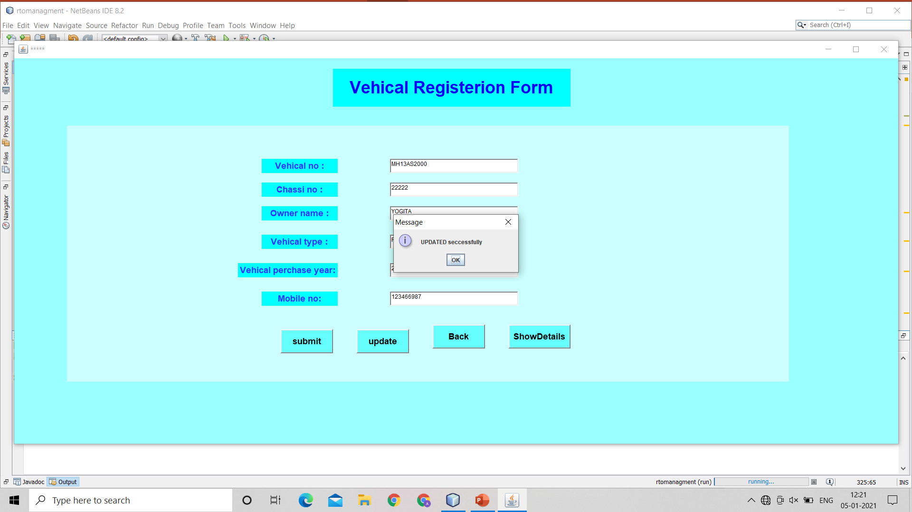

THIS IS VEHICAL REGISTRATION PAGE

5.PAGE NO

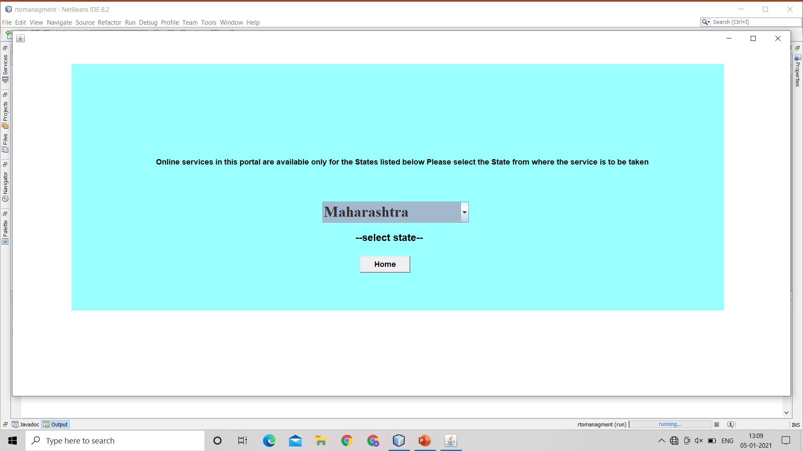

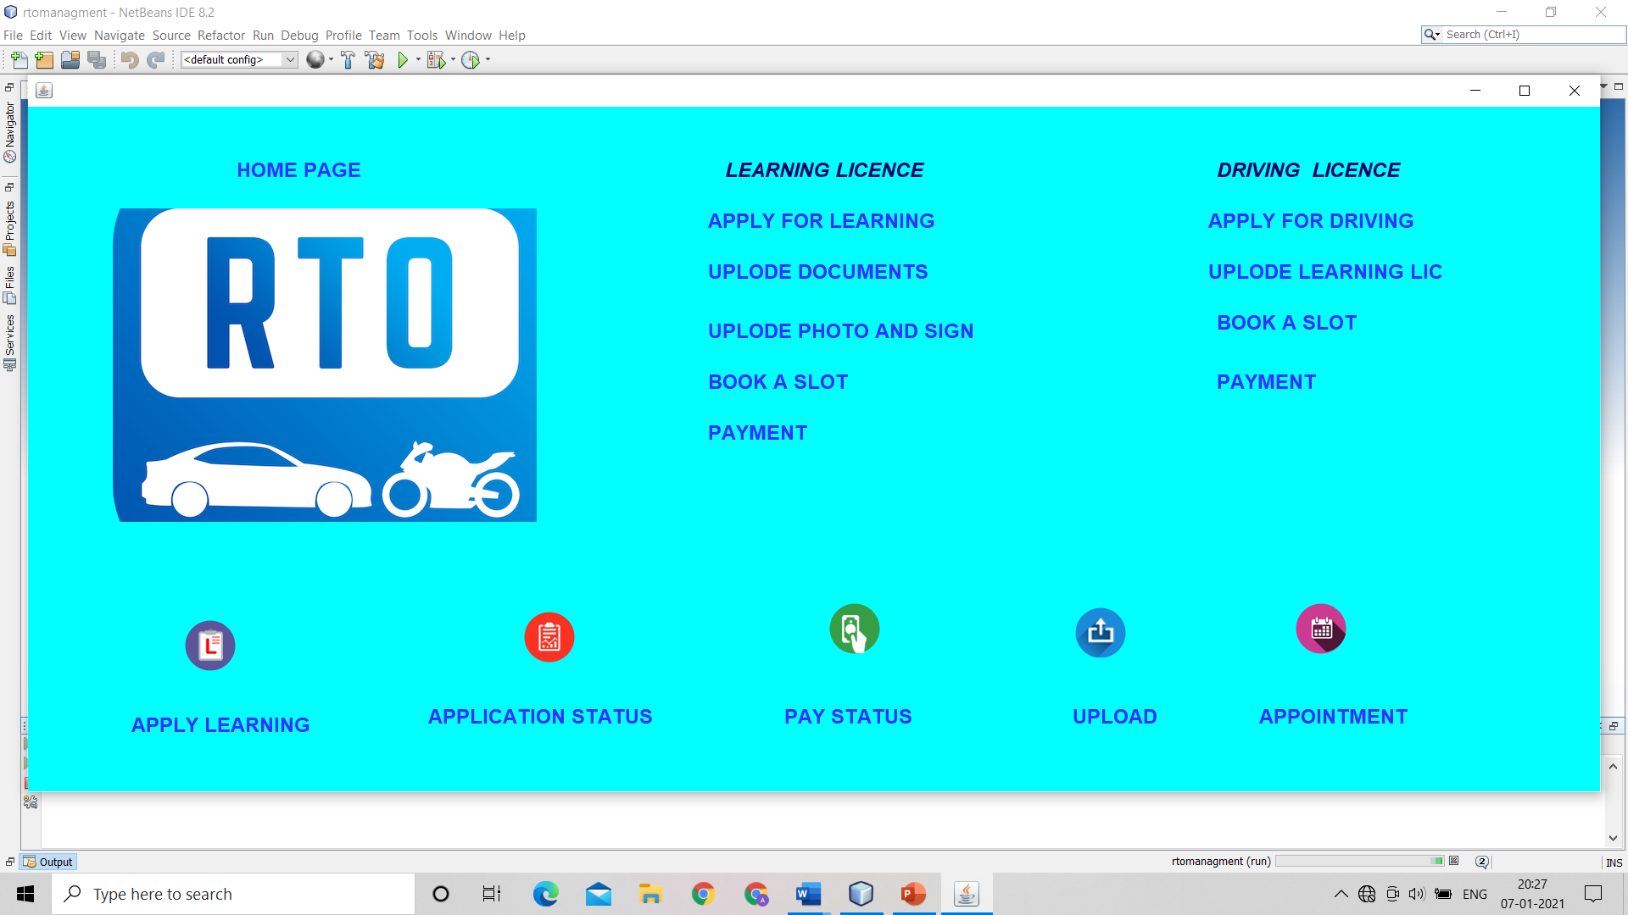

THIS IS LICENCE HOME PAGE

5.PAGE NO

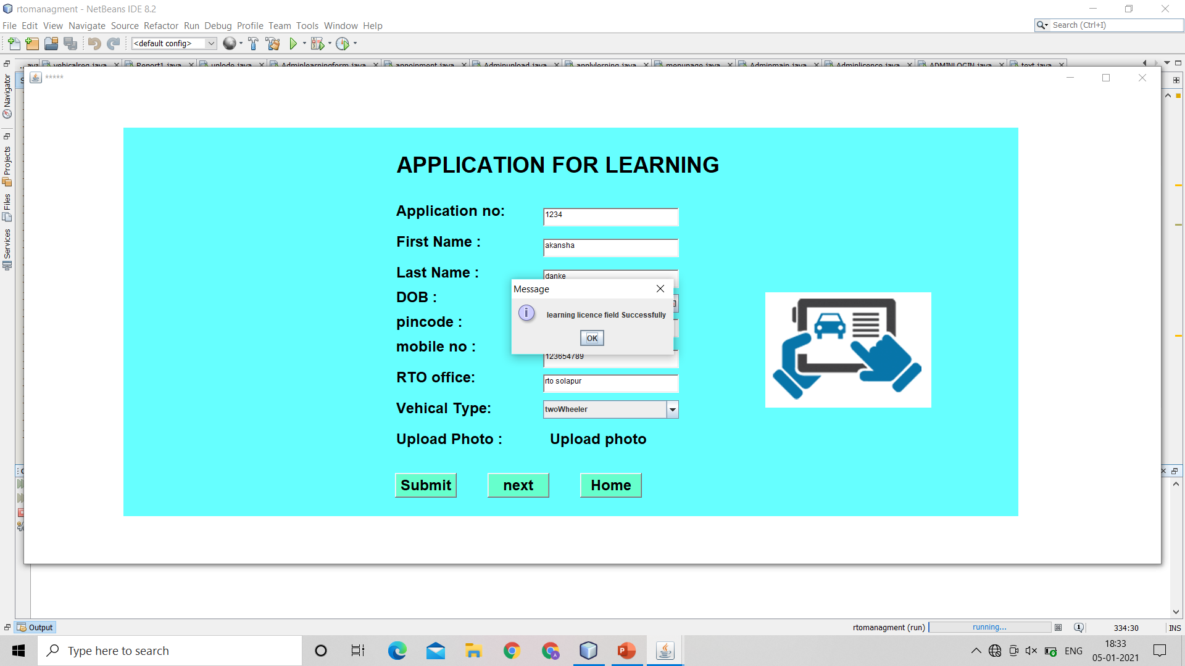

THIS IS LICENCE FORM PAGE

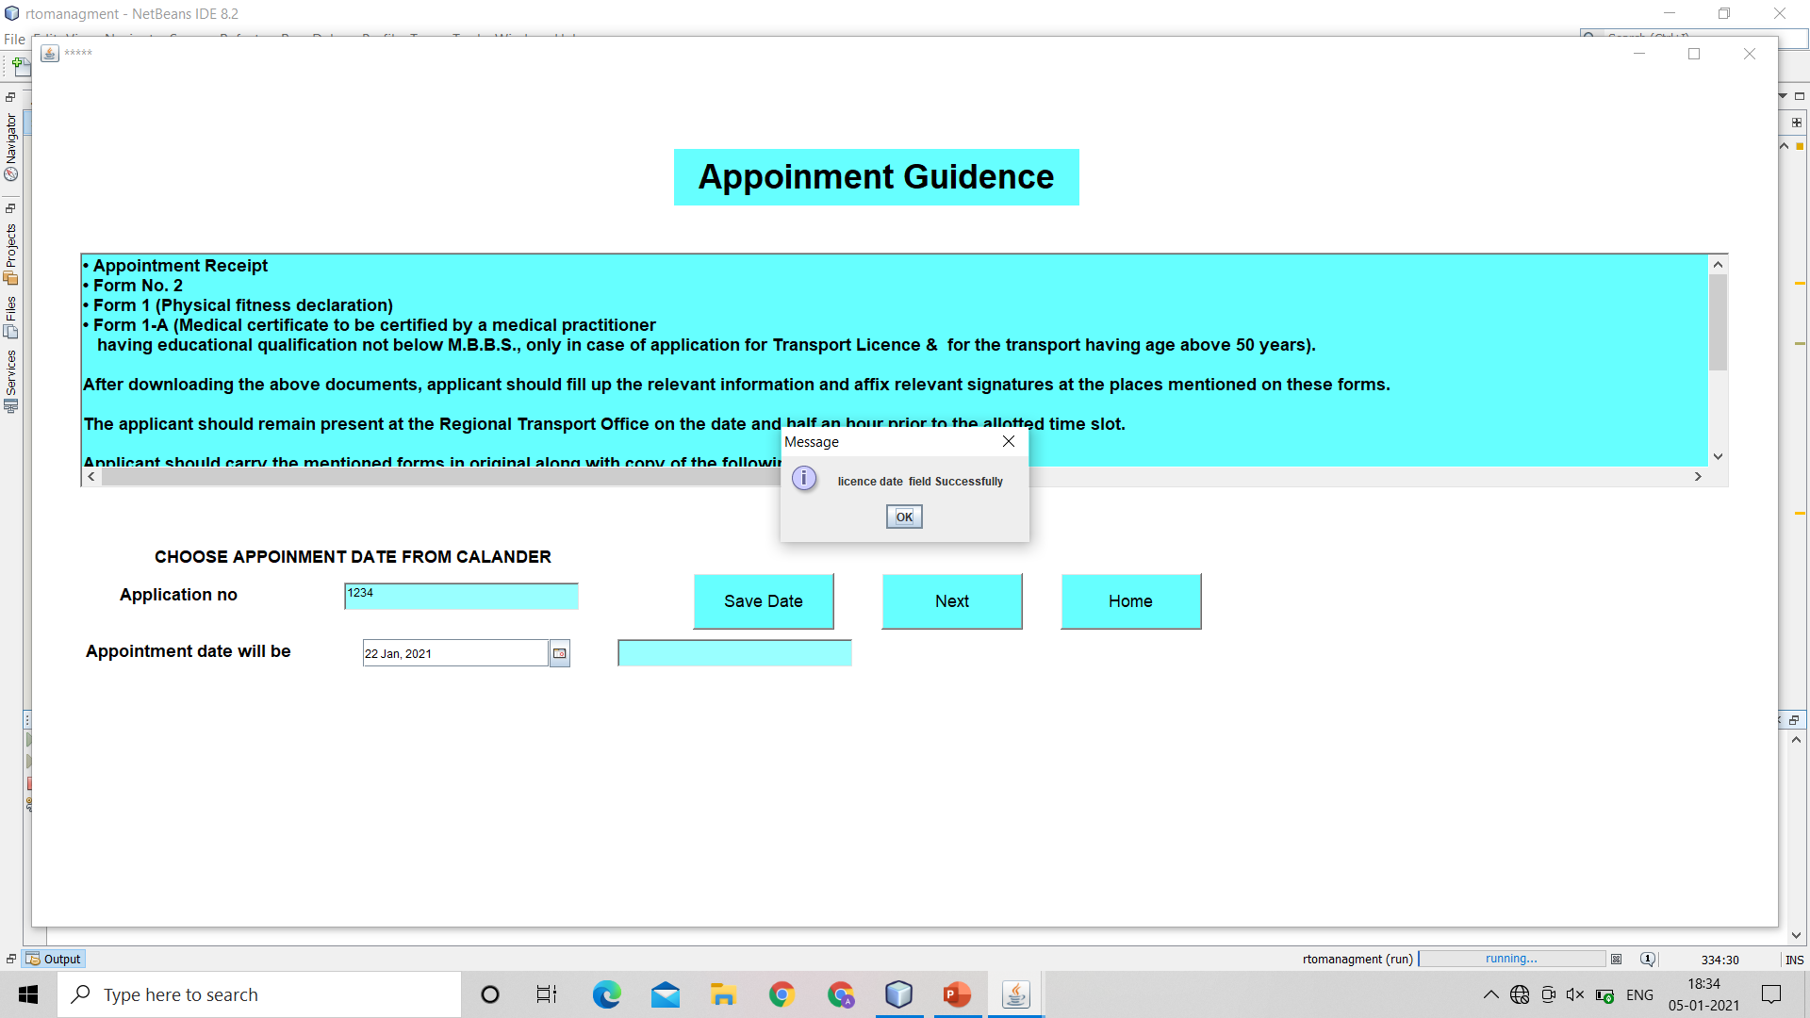

THIS IS LICENCE FORM PAGE

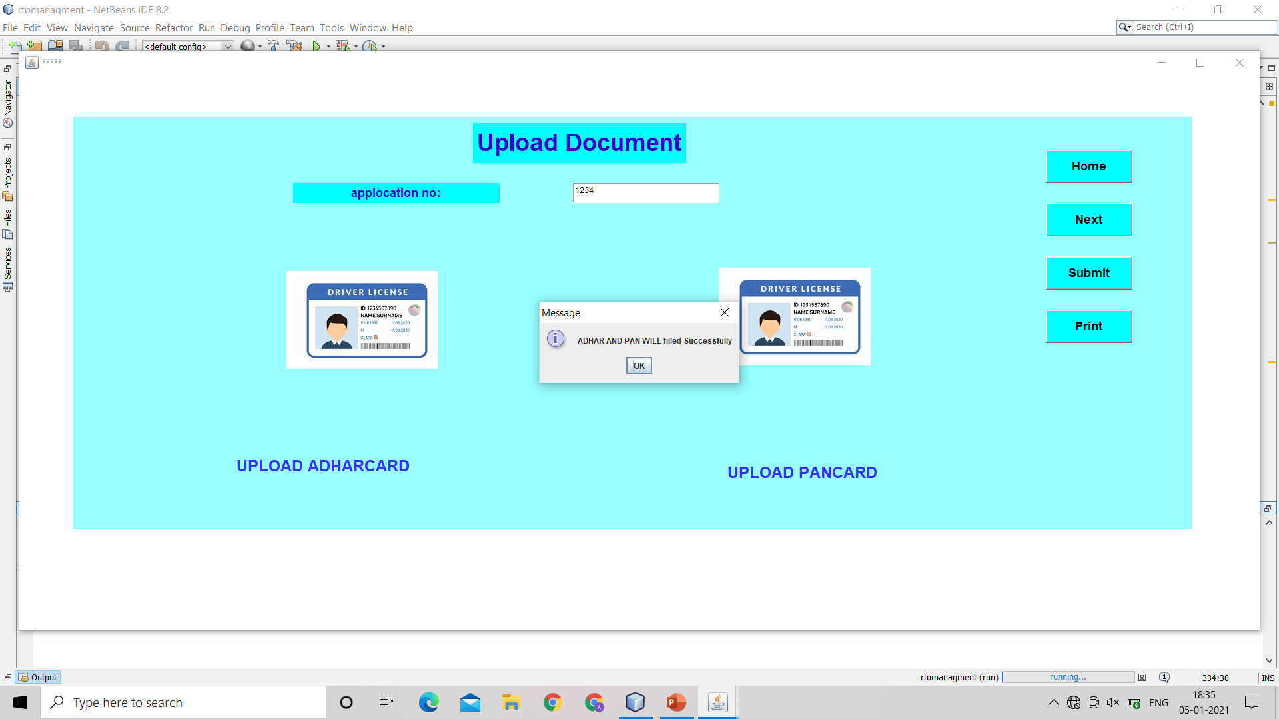

THIS IS DOCUMENT UPLOAD FORM PAGE

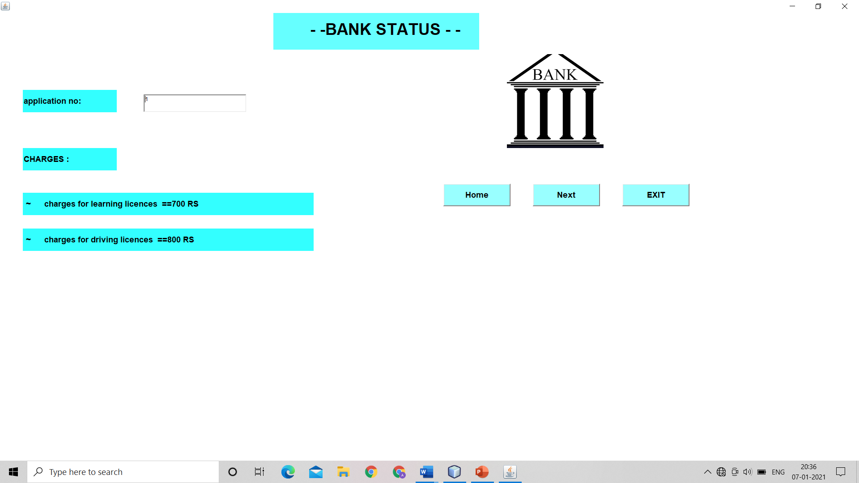

THIS IS PAYMENT FORM PAGE

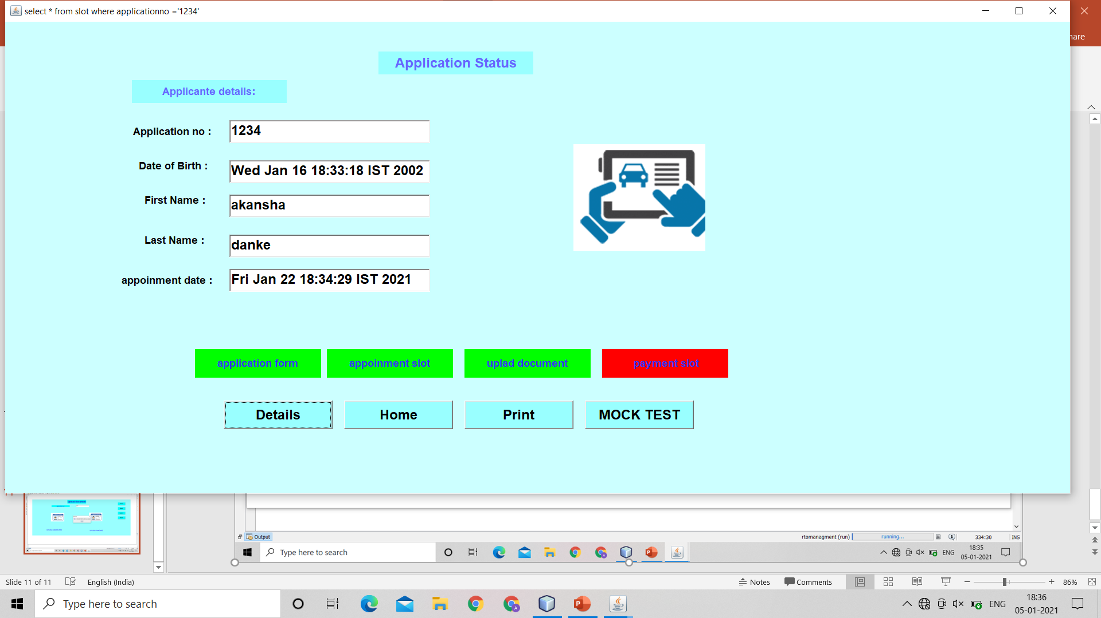

THIS IS STATUS FORM PAGE



THIS IS MOCK TEST PAGE

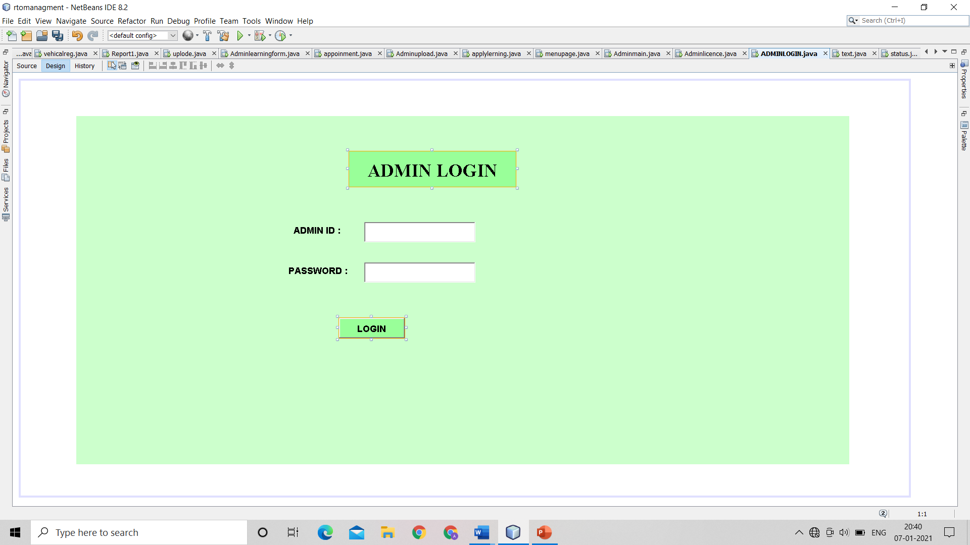

THIS IS ADMIN LOGIN PAGE

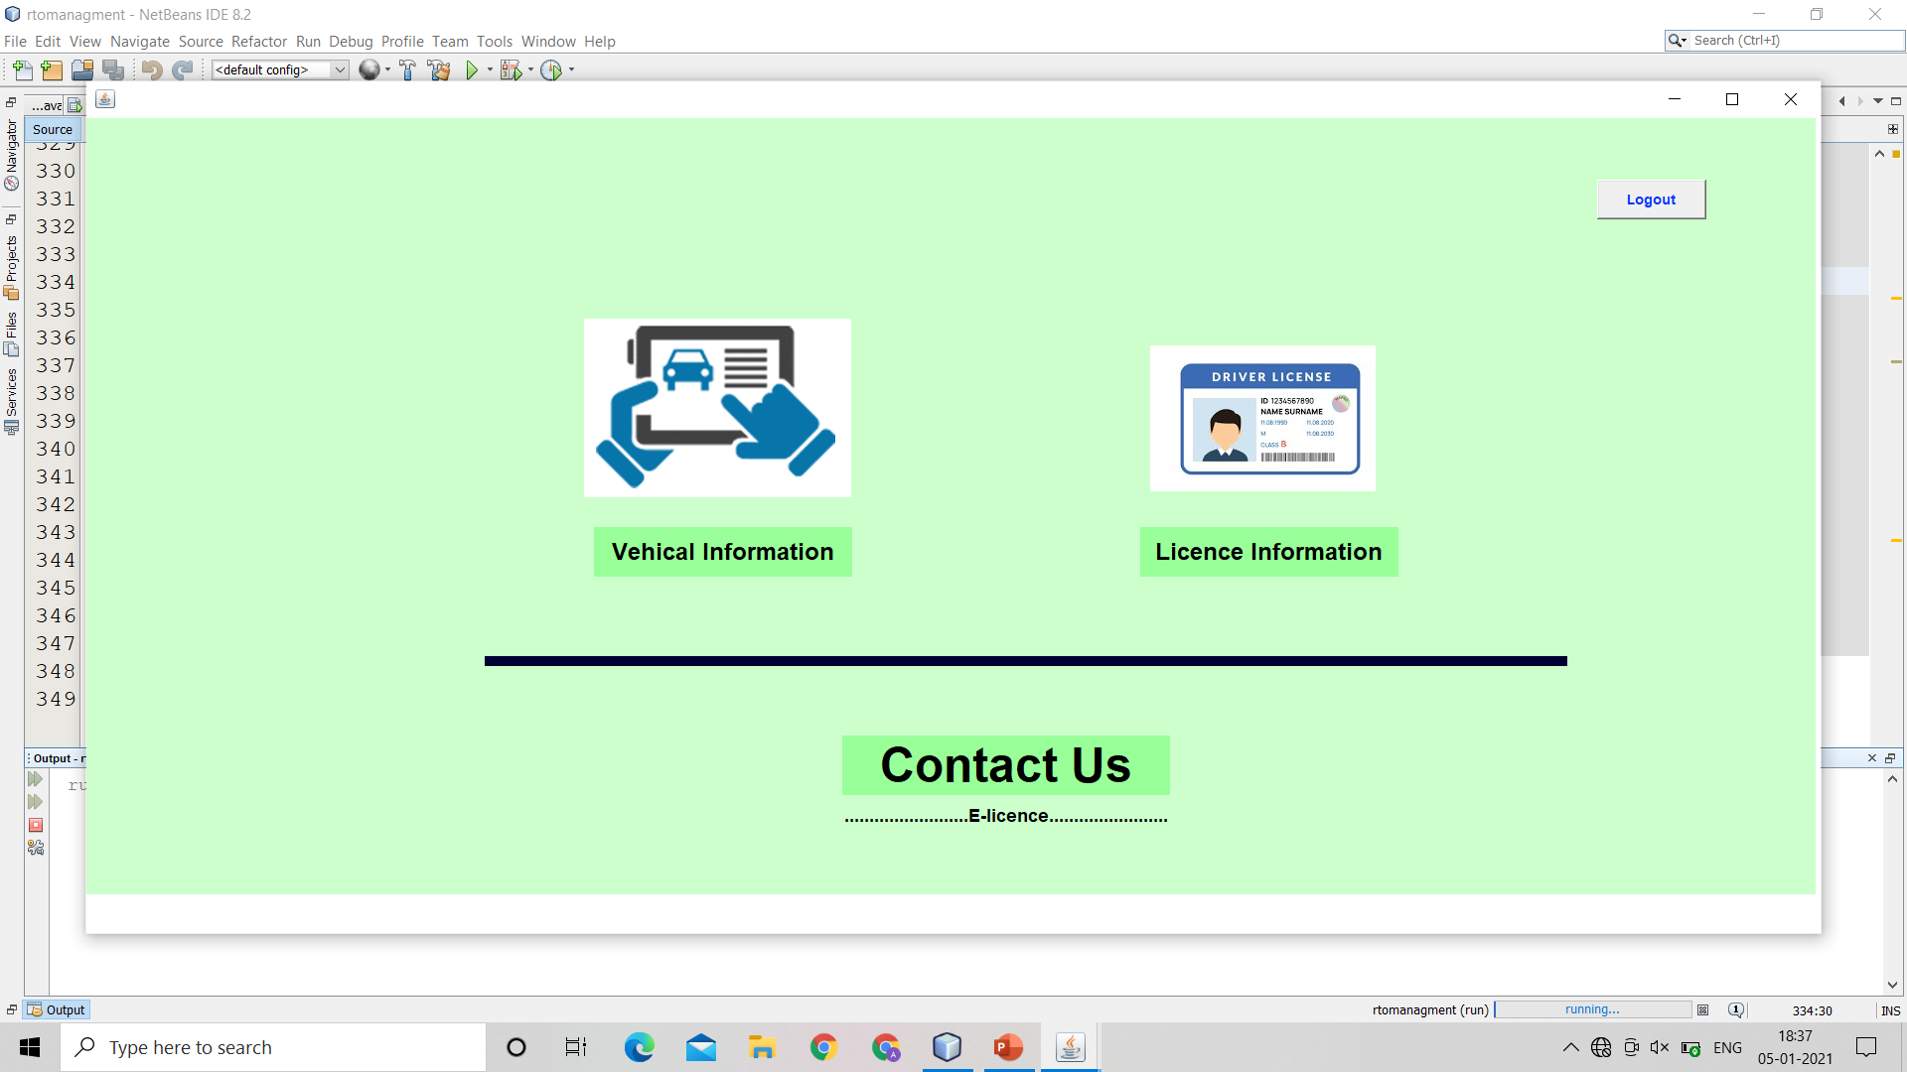

THIS IS ADMIN HOME PAGE

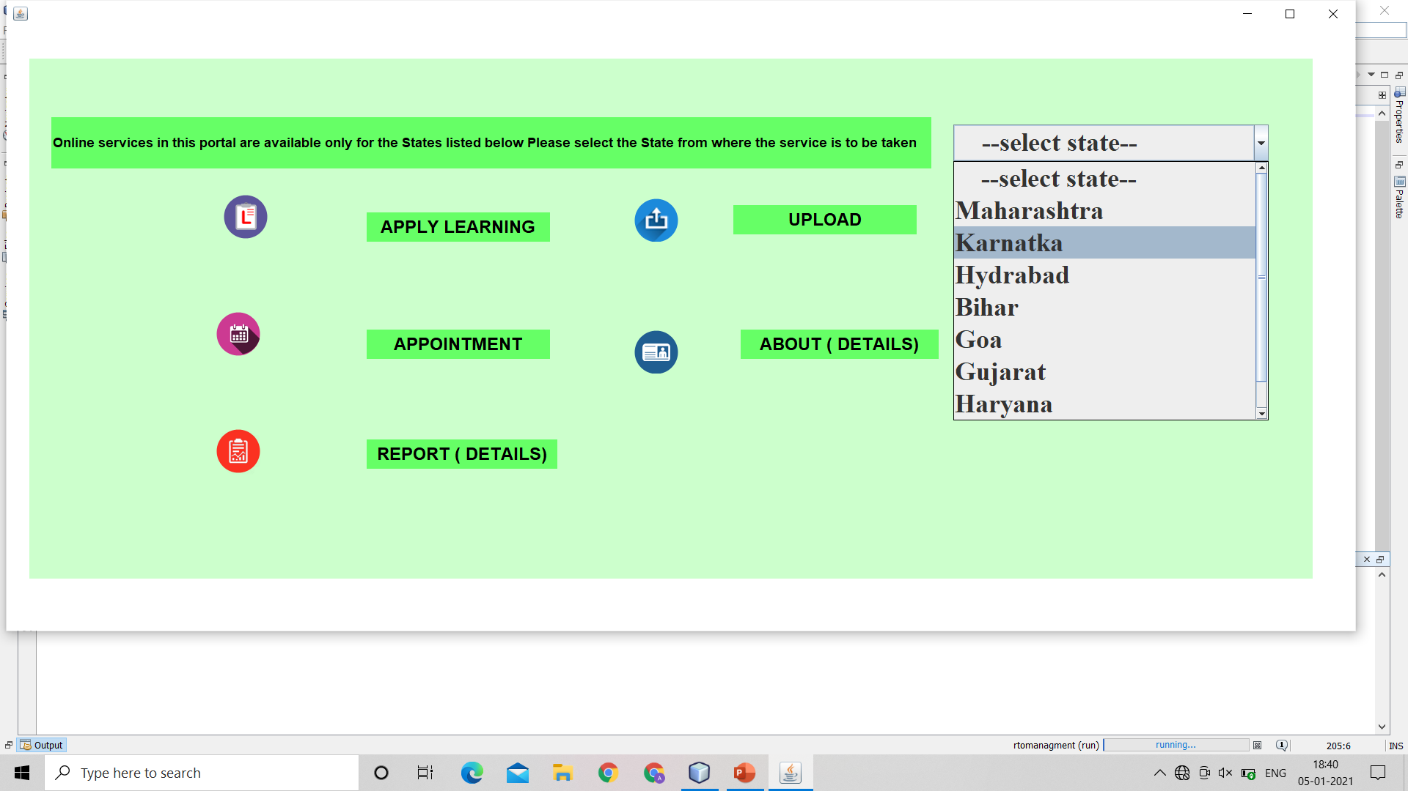

THIS IS ADMIN MAIN PANEL PAGE

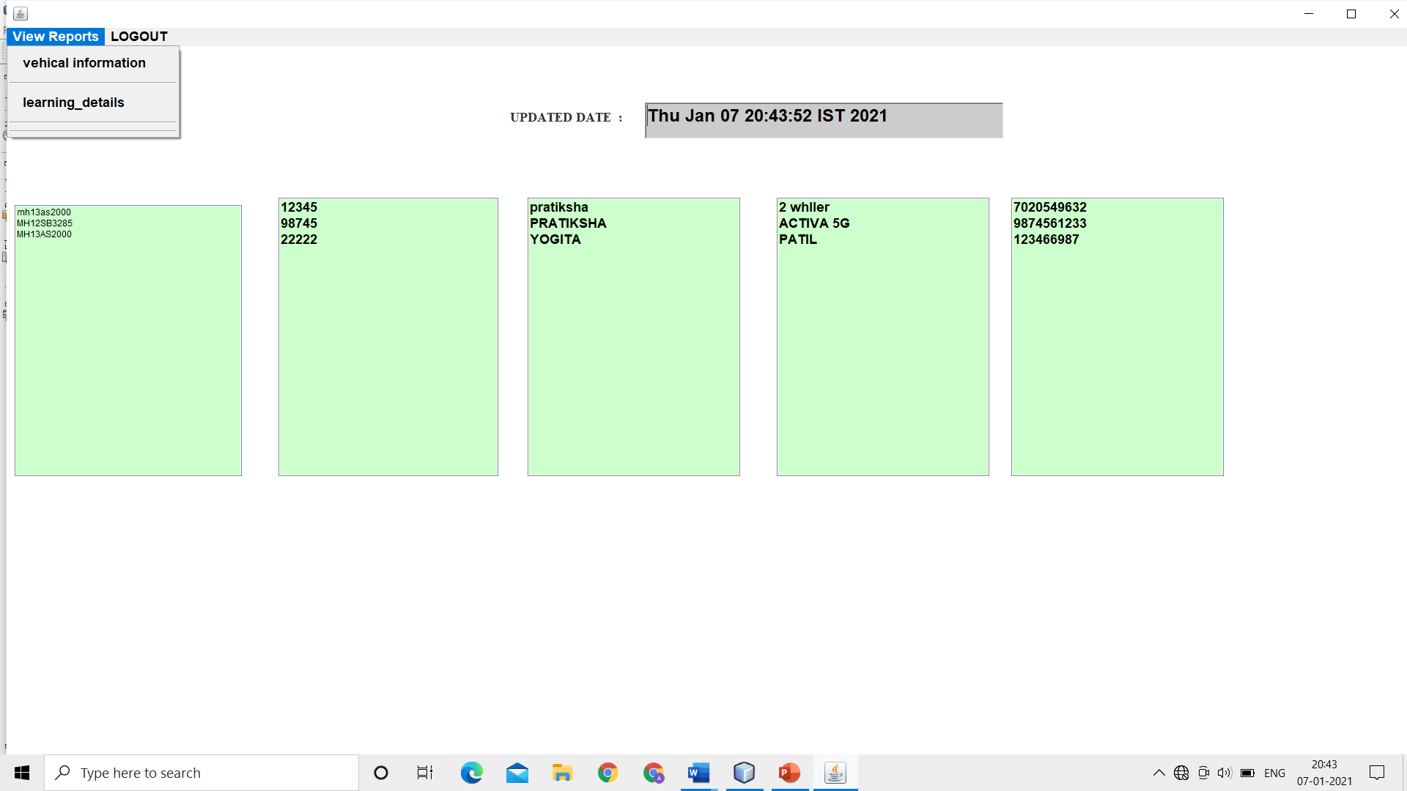

THIS IS ADMIN report PAGE

# 4.IMPLEMENTATION

**1. Admin Login**

This form is use to admin login.

1. **Admin Home Page**

This form is the admin home page.

1. **Home page**

The admin can update or insert lincence or vehical deatils form.

1. **REPORT**

The admin can see ALL DEAILS OR LIST OF DEATILS form.

1. **Registered users**

The admin can see the registered users.

1. **REGISTED VEHICAL**

The admin can see the REGISTED VEHICAL DEATILS.

1. **User Home Page**

This is the user home page.

1. **VEHICAL REGISTATION PAGE**

The user can add NEW VEHICAL AND ALSO UPDATE VEHICAL DETAILS WITH OWNER DETAILS.

1. **User Login**

The user can login and create account using this form.

This form is USED TO REGISTER NEW USER.

1. **User REGISTRATION**

The user can login USED TO REGISTER NEW USER.

1. **LINCENCE FILL UP FORMS**

The user can WRITE OWN DETAILS AND GET APPOINMENT AND THEN UPPLOAD DOCUMENT AND FEE PROCESS.

1. **STATUS FORMS**

The user can SEE WHETHER HE FILLED IS WRITE OR WRONG.

**5.ADVANTAGES AND LIMITATIONS**

**5.1. Advantages:**

* It gives all information about the LINCENEC AND VEHICAL FROM RTO etc..
* It saves time.
* It saves a lot of paper work.
* Don’t go the outside and finding the shop OR RTO IN YOUR CITY OR AGENT .

**5.2 Limitations:**

* MUST BE REQUIRED THE APPLICATION IS PRESENT ON USER LAPTOP OR COMPUTER.
* Only register user can login.
* USER CANNOT PRINT FORM INTHIS APPLICATION.
* USER CANNOT MAKE ONLINE PAYMENT
* Only admin can add, update and delete items.

# 6.CONCLUSION

**6. CONCLUSION**

In our project the user can access all information about RTO AND LICENCE AND VEHICAL DETAILS . We develop this project for help the user to guide them about LINCENC AND VEHICAL REGISTRATION DEATILS. To establish this project we use various methodologies. To develop this project we have faced many problems but we hardly tried to develop this project. Our supervisor helps us by giving this valuable opinion, decision and time.

## 7.BIBLIOGRAPHY

**7. Bibliography:**

1. [www.tutorialspoint.com](http://www.tutorialspoint.com/)
2. [www.javatpoint.com](http://www.javatpoint.com/)